**DAILY ONLINE ACTIVITIES SUMMARY**

|  |  |  |  |
| --- | --- | --- | --- |
| **Date:** | 6/07/2020 | **Name:** | Krishnitha |
| **Sem & Sec** | 4th sem, A Section | **USN:** | 4AL18CS039 |
| **Online Test Summary** | | | |
| **Subject** | NA | | |
| **Max. Marks** | NA | **Score** | NA |
| **Certification Course Summary** | | | |
| **Course** | Lightning Experience Customization | | |
| **Certificate Provider** | salesforce | **Duration:** | 3 hrs |
| **Coding Challenges** | | | |
| **Problem Statement:**  Write a Java program to find the Nth natural number with exactly two bits set. | | | |
| **Status:** Executed | | | |
| **Uploaded the report in GitHub** | | YES | |
| **If yes Repository name** | | <https://github.com/krishnitha/Java-coding> | |
| **Uploaded the report in slack** | | YES | |

**Certification Course Details:**

Today I started the new course “Lightning Experience Customization” by salesforce. Today I learnt about business value of custom objects and fields, the benefits of Lightning app. And also learnt how to create and edit custom objects and fields, create custom tab for a custom object

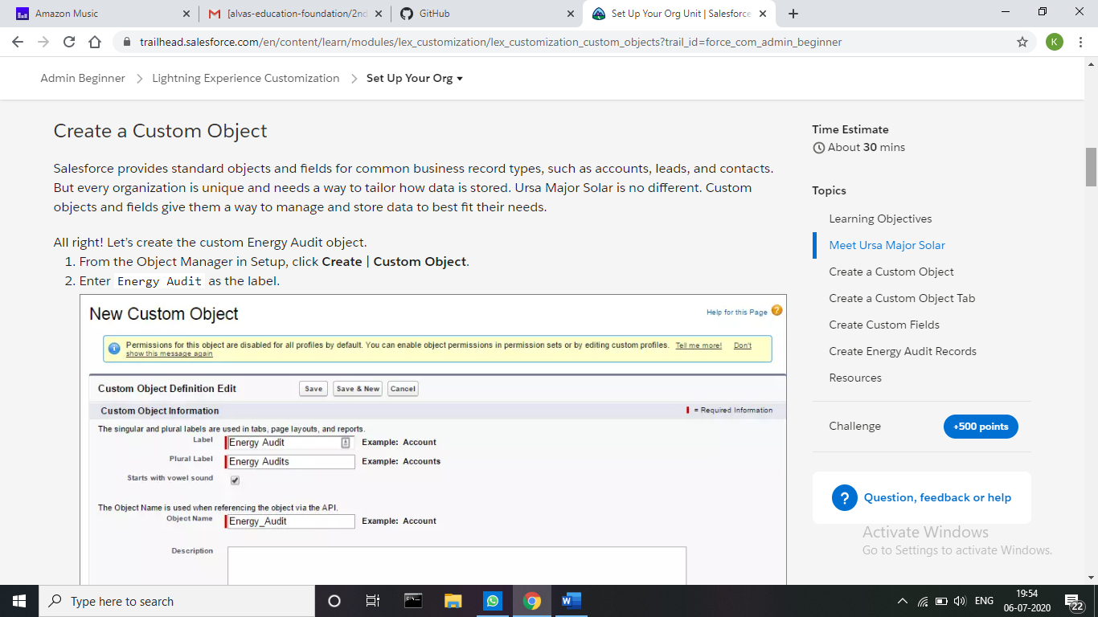

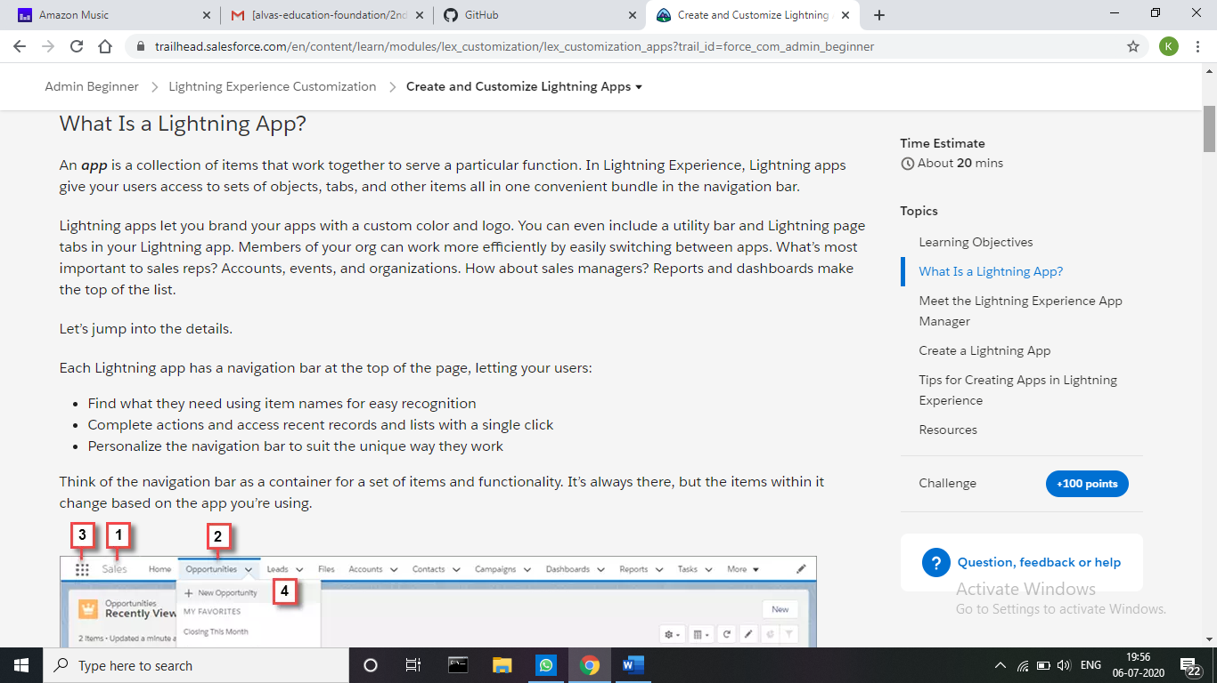

**Webinar Details:**

Today I attended a webinar on “Salesforce - Job ready program” by Manaswi, Neetu Bansal and Aviral Agarwal and “TCS iON Session on How to use Remote Internship Opportunities” by Kamal Jadhwani. These session were very interesting and spoke about the various fields in which students should work hard.

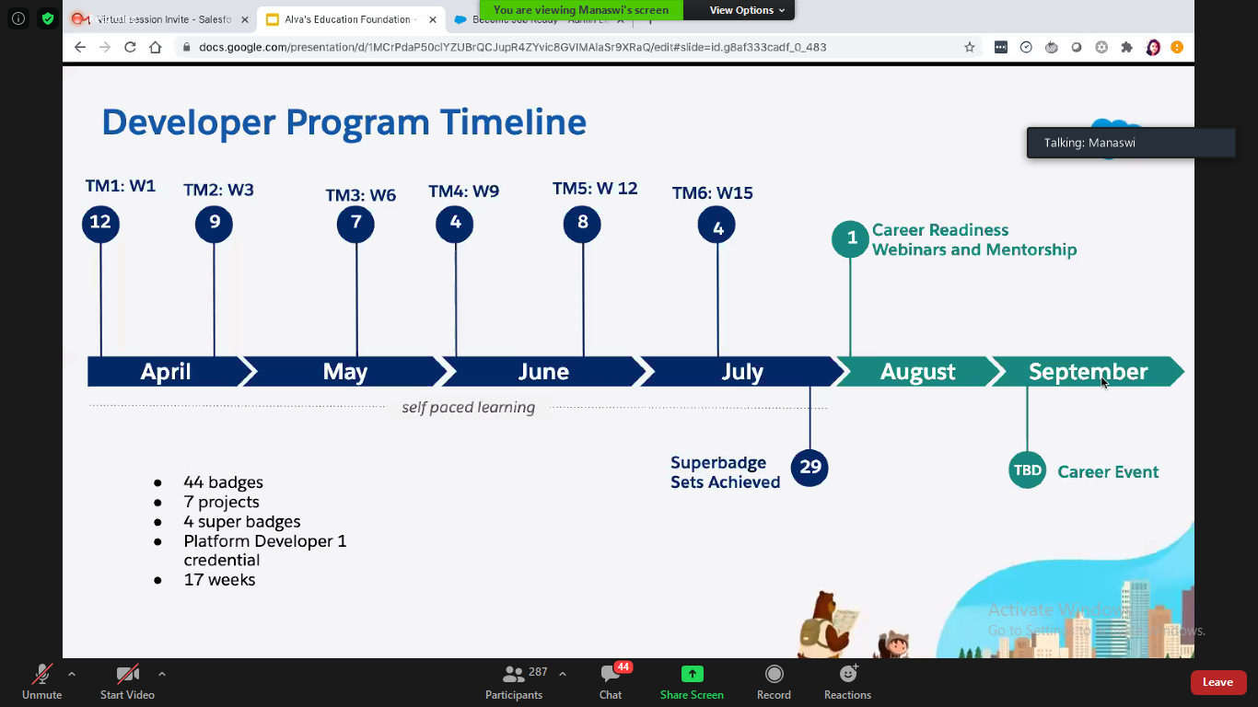

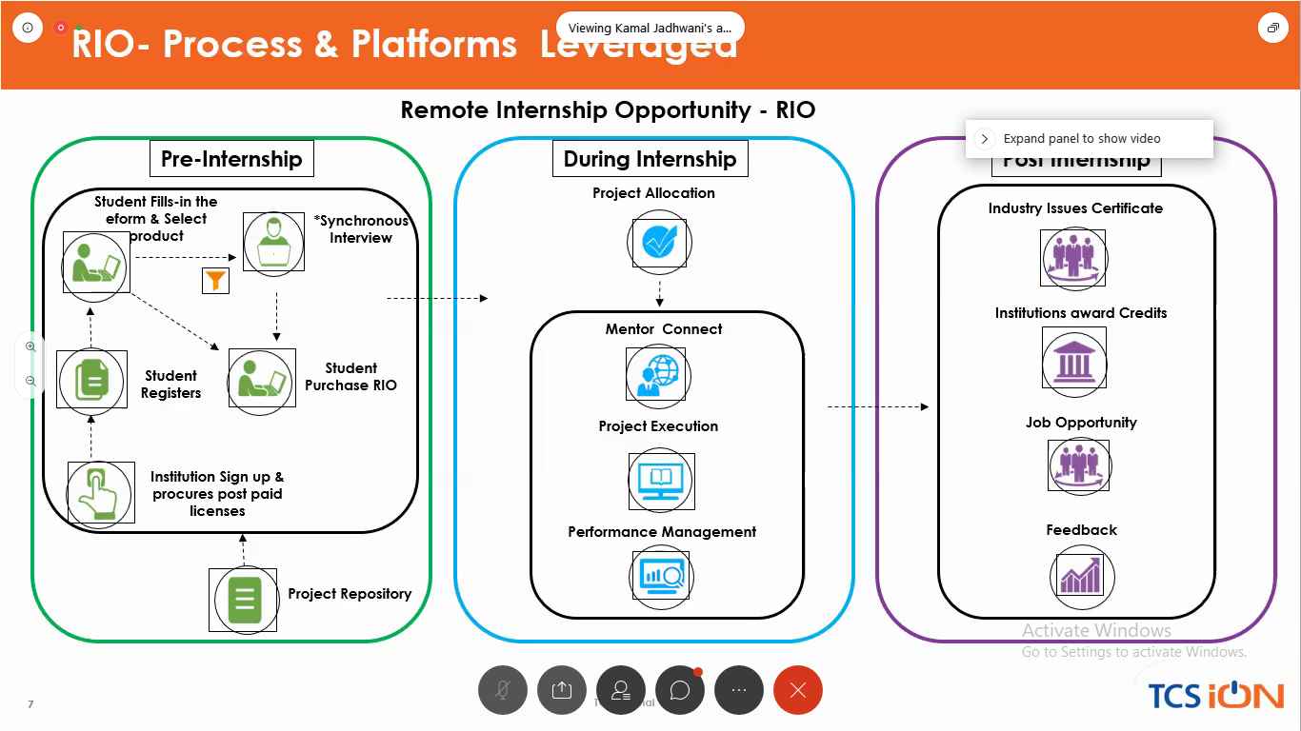

**Coding Challenges Details:**

**Problem:** Write a Java program to find the Nth natural number with exactly two bits set.

Given an integer N, the task is to find the Nth natural number with exactly two bits set.

**Examples:**

Input: N = 4  
Output: 9

Input: N = 15  
Output: 48

**Hint**  
Explanation: of 1st example  
Binary representation of numbers 1 -0001, 2- 0010, 3- 0011, 4-0100, 5-0101, 6-0110, 7- 0111, 8-1000, 9 - 1001, 10- 1010 etc. Here only for the bold numbers binary values contains exactly 2 bits 1's hence  
Numbers with exactly two bits set: 3, 5, 6, 9, 10, 12, …  
4th number in this is 9.

Therefore, output is 9

**Solution:** Uploaded it in GitHub

